# Mean Image per Each Class

|  |  |  |  |
| --- | --- | --- | --- |
| Class 0  **airplane** |  | Class 5  **dog** |  |
| Class 1  **automobile** |  | Class 6  **Frog** |  |
| Class 2  **Bird** |  | Class 7  **horse** |  |
| Class 3  **cat** |  | Class 8  **ship** |  |
| Class 4  **deer** |  | Class 9  **truck** |  |

# Plot Average Sum of Squared Pixel Wise Difference between (Reconstructed Image Vs Original Image)

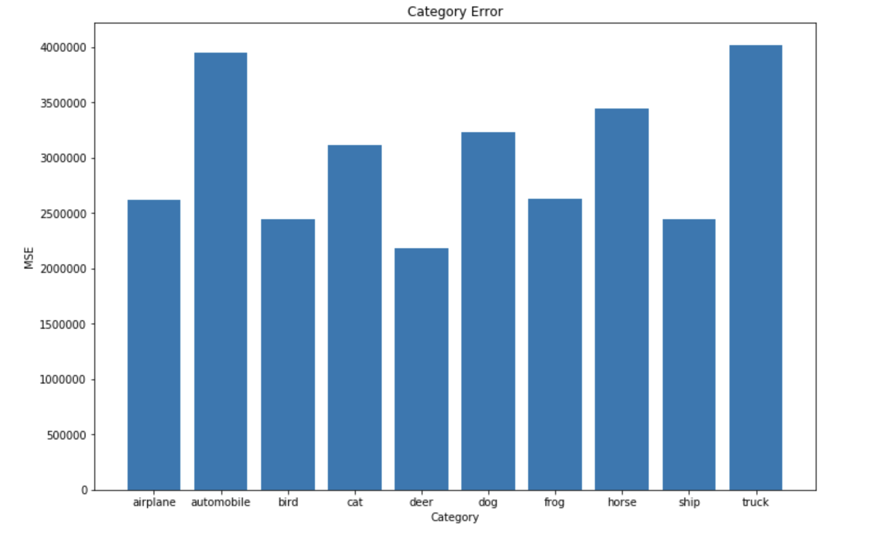

# 2 D Scatter Plot (Principal Co-ordinate Analysis) – Part B

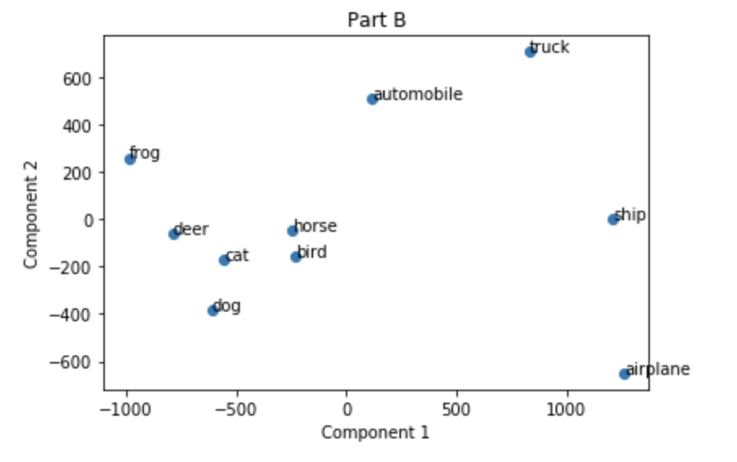

# 2 D Scatter Plot (Principal Co-ordinate Analysis) – Part C

